**Problem Statement:**

**To understand how to create web services project using WADL.**

**Steps to execute:**

**To create a web services project - Pick any End points from the below**

[**http://zero.webappsecurity.com/web-services/secureInfoService?wadl**](http://zero.webappsecurity.com/web-services/secureInfoService?wadl)

1. **Take any WADL from the project or from public domain**

**Ans.**

[**http://webservices.oorsprong.org/websamples.countryinfo/CountryInfoService.wso?wadl**](http://webservices.oorsprong.org/websamples.countryinfo/CountryInfoService.wso?wadl)

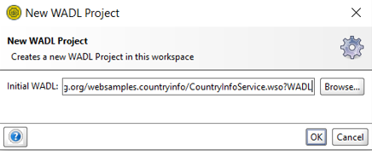

1. **Identify endpoint based on the input created.**

**Ans.**

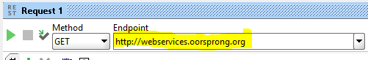

1. **Construct input and output XML**

**Note: If the above is done using WADL from public domain, use their input to hit the service and get the output. Validate the o/p against specified in WSDL**

**Ans.**

OUTPUT XML

INPUT XML

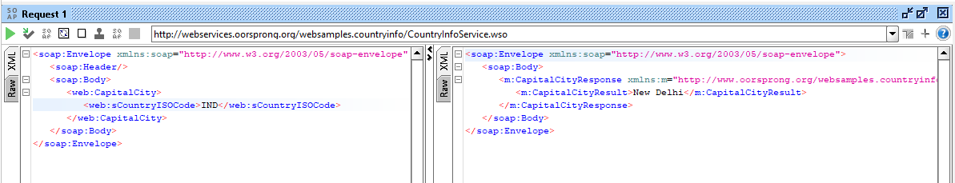

OUTPUT XML

INPUT XML

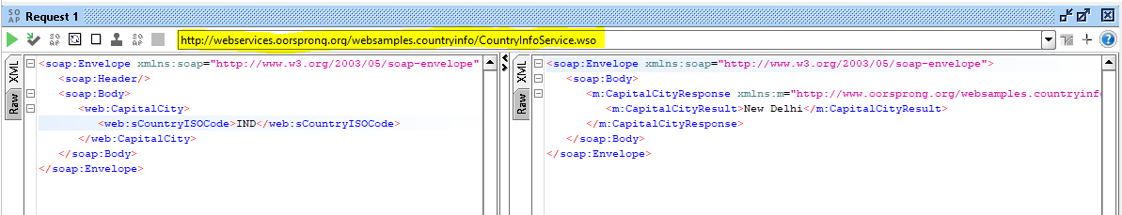

1. **Modify the WADL to reinforce understanding – example : convert one or 2 things such as changing response output from XML to JSON or vice-versa**

**Ans.**

